**Report on the Neural Network Model**

**Overview** of the analysis: Explain the purpose of this analysis.

* The purpose of this analysis is to understand why and how the neural network model is used in real life practices. By taking a deeper look, we can see what variables are necessary to achieve the results we need.

**Results**: Using bulleted lists and images to support your answers, address the following questions:

* Data Preprocessing
  + What variable(s) are the target(s) for your model?
    - IS_SUCCESSFUL
  + What variable(s) are the features for your model?
    - APPLICATION_TYPE, AFFILIATION, CLASSIFICATION, USE_CASE, ORGANIZATION, STATUS, INCOME_AMT, SPECIAL CONSIDERATIONS, ASK_AMT,
  + What variable(s) should be removed from the input data because they are neither targets nor features?
    - NAME, EIN
* Compiling, Training, and Evaluating the Model
  + How many neurons, layers, and activation functions did you select for your neural network model, and why?
    - As seen below, I chose 2 hidden layers and used relu and sigmoid activation functions for my neural network model. The amount of neurons I chose initially was 80, 30, and 1. I those to go this route to adhere closely to examples and what I’ve learned thus far as a base. I later on adjusted this to see if I could get a better accuracy score as entailed ahead.

* + Were you able to achieve the target model performance?

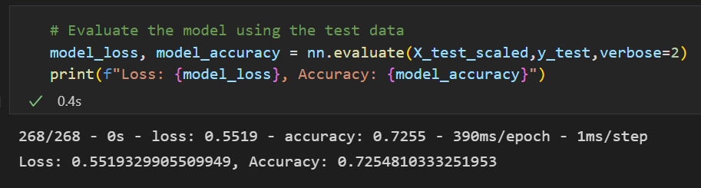

* + - I was unable to achieve the 75% accuracy goal.
  + What steps did you take in your attempts to increase model performance?
    - I’ve taken multiple steps to improve the model performance, however I was unsuccessful in achieving the 75% accuracy. I added another hidden layer, changed the epochs to =100, and tried numerous different parameter units.

**Summary**:

* I had a loss of 55.19% and an accuracy score of 72.55%. I would suggest to continue trying out more methods in acquiring a higher accuracy score. At this time, this model may not be ready for practical use.